AIR QUALITY INDEX ANALYSIS DASHBOARD

# PROJECT REPORT

### Submitted by

### VASANTHARAN K (21ADR056)

### SABARI S (21ADR042)

### PRETHISH G A (21ADR035)

### SANKAR V (21ADL066)

***for***

# 20ADC33 DATA ANALYSIS

# DEPARTMENT OF ARTIFICIAL INTELLIGENCE



**KONGU ENGINEERING COLLEGE**

# (Autonomous)

**PERUNDURAI ERODE – 638 060**

# DECEMBER 2022

**KONGU ENGINEERING COLLEGE**

### (Autonomous) PERUNDURAI ERODE – 638 060

DECEMBER **2022**

Department of Artificial Intelligence

**20ADC33 – Data Analysis Project Report**

Signature of course in-charge Signature of the HOD

Submitted for the continuous Assessment viva voice examination held on __ _.

**EXAMINER I EXAMINER II**

# ABSTRACT

Public health has been seriously impacted by air pollution in developing nations where the population is expanding quickly. Fine particulate matter is one type of pollution that has been linked to a number of major health issues, such as asthma, cancer, cardiovascular disease, and respiratory illnesses. Monitoring the AQI level will help the public and decision-makers become more aware of the need to address the issue of air pollution. The AQI is calculated by the Environmental Protection Agency for five primary air pollutants: nitrogen dioxide (NO2), ground-level ozone (O3), particle pollution (PM10 and PM2.5), carbon monoxide (CO), and Sulphur dioxide (SO2).

The creation and publication of a dashboard is the only method to address this issue. With the use of a dashboard, people can easily understand the AQI status and how the air will be. The AQI dashboard is made using the Microsoft Power BI Dashboard service. Users can quickly review reports and observe all key KPIs by using a Power BI dashboard. Users can generate visualizations from numerous datasets or reports using a Power BI dashboard. Dashboards can be altered to suit the needs of every organization.

# TABLE OF CONTENTS

|  |  |  |
| --- | --- | --- |
| **CHAPTER**  **No.** | **TITLE** | **PAGE NO.** |
|  | **Abstract** | III |
|  | **LIST OF FIGURES** | V |
| 1. | **INTRODUCTION** | **7** |
|  | 1.1 INTRODUCTION | 7 |
|  | 1.2 DATA COLLECTION | 8 |
|  | 1.3 PROBLEM STATEMENT | 9 |
|  | 1.4 BUSINESS OBJECTIVE | 9 |
| **2.** | **DATA PREPARATION AND MODELING** | **10** |
|  | 2.1 DATA CLEANING | 10 |
|  | 2.2 DATA TRANSFORMATION | 12 |
|  | 2.3 DATA MODELLING | 14 |
| **3.** | **DATA ANALYSIS AND INTERPRETATION** | **16** |
|  | 3.1 DATA ANALYSIS | 16 |
|  | 3.2 PUBLISHING DASBOARDS | 31 |
|  | 3.3 INFERENCE | 32 |
| **4.** | **CONCLUSION** | **37** |
|  | 4.1 RECOMMENDATIONS | 37 |
| **5.** | **REFERENCES** | **38** |

# LIST OF FIGURES

|  |  |  |
| --- | --- | --- |
| **FIGURE No.** | **FIGURE NAME** | **PAGE No.** |
| 2.1. | Raw Dataset in Power Query Editor | 11 |
| 2.2. | Initial Removal of Null and Blank values | 11 |
| 2.3. | Dataset with completing Data Cleaning process | 12 |
| 2.4. | First row is changed as Header | 13 |
| 2.5. | Month and Year column are created | 13 |
| 2.6. | Tables for analysis are created | 14 |
| 2.7. | Relationship between tables | 15 |
| 3.1 | AQI Bucket during 2015, 2016 and 2017 | 17 |
| 3.2 | AQI Bucket status in 2020 | 18 |
| 3.3 | Air Quality based on CO | 19 |
| 3.4 | AQI Bucket comparison between Delhi and Hyderabad in 2019 | 20 |
| 3.5 | City with highest AQI value | 21 |
| 3.6 | Comparison of AQI and AQI bucket in 2018 | 22 |
| 3.7 | City with High NO and NO2 content during Jan 2020 | 22 |
| 3.8 | Value of NO2 in month December of 2015, 2016, 2017 and 2018 | 23 |
| 3.9 | Comparison of NO and NO2 value in Jan 2016 | 24 |
| 3.10 | Air composition level for all cities in 2019 | 24 |
| 3.11 | City with high toluene content in 2020 | 25 |
| 3.12 | Element causing more pollutions in 2017 | 25 |
| 3.13 | Level of NO2 and NO in each city during 2020 | 26 |
| 3.14 | Amount of air pollutants in air of each city during 2019 | 27 |
| 3.15 | Amount of PM10 content for each month in the year 2019 | 27 |
| 3.16 | Level of CO and NO in each city during 2017 | 28 |
| 3.17 | Comparison of SO and PM2.5 in year 2018 for each month | 29 |
| 3.18 | City with highest NOx value in 2019 | 29 |
| 3.19 | Amount of toluene and xylene in air during summer months of 2015 | 30 |
| 3.20 | Amount of benzene in air during the winter of 2015 | 30 |
| 3.21 | Air Quality Index Dashboard | 31 |

# CHAPTER 1 INTRODUCTION

## INTRODUCTION

## Government agencies use an air quality index (AQI) to Inform the public of the air's current or historical pollution levels is expected to become. Data from an air quality sensor, which can increase due to vehicle traffic, forest fires, or any other cause of air pollution, are averaged to get the AQI. Ozone, nitrogen dioxide, and sulphur dioxide are only a few of the pollutants that were tested. As the AQI rises, there are more dangers to the general public's health, particularly for young children, the elderly, and people who already have respiratory or cardiovascular conditions. Among the pollutants tested were ozone, nitrogen dioxide, and Sulphur dioxide. As the AQI rises, so do the threats to public health, particularly for children, the elderly, and anyone with respiratory or cardiovascular difficulties. During these times, governments often recommend citizens limit their outdoor physical activity or perhaps avoid going out completely. Face masks, such as cotton masks, may also be advised.

## An air monitor or model can be used to determine the air pollutant concentration over a certain averaging period, which is required by the AQI. When concentration and time are added together, they reflect the dose of the air contaminant. Epidemiological studies establish the health effects associated with a certain dose. The potency of air pollutants varies, as does the function used to convert air pollutant concentration to AQI. Its air quality index values are usually classified into ranges. Each range is given a descriptor, a color designation, and a public health advisory. The AQI may rise as a result of increased air pollution. For example, during rush hour traffic, when there is an upwind forest fire, or when air contaminants are not adequately diluted. High pollutant concentrations, chemical interactions between air pollutants, and foggy conditions are all created by stagnant air, which is typically brought on by an anticyclone, a temperature inversion, or low wind speeds.

## The definition of the AQI in each country reflects the debate over the formulation of national air quality standards in that country. A website has just been launched that allows government organizations all over the world to contribute real-time air monitoring data for display using a uniform definition of the air quality index. Since many years ago, provincial air quality indices have been used to report air quality (AQIs). Significantly, rather than being only focused on protecting human health, AQI values represent air quality management objectives that are based on the lowest practicable emissions rate.

The analyzing tool which is used for the Air Quality Index analysis is Microsoft Power BI. Microsoft's Power BI is an interactive data visualization software programmed with a main emphasis on business intelligence. The Microsoft Power Platform includes it. Power BI is a collection of software services, programmers, and connections that work together to turn various data sources into appealing, interactive visualizations. A database, website, or structured files like spreadsheets, CSV, XML, and JSON can be directly read for data entry. Power BI offers desktop-based Power BI Desktop and cloud-based BI (business intelligence) services, collectively referred to as "Power BI Services." It delivers interactive dashboards, data discovery, and data preparation tools for data warehouses. On its Azure cloud platform, Microsoft introduced a new service called Power BI Embedded in March 2016.

## The AQI database contains thousands of records, some of which might have typos, empty cells, or null values. Analyzing the raw AQI data will be more challenging. Even if it has already been preprocessed, analyzing it as an Excel or CSV document will be time-consuming and tiresome. The only way to deal with this problem is to create and publish a dashboard. Using a dashboard, people can easily understand the AQI status and how the air will be. The Microsoft Power BI Dashboard service was used to create the AQI dashboard. Using a Power BI dashboard, users can easily analyze reports and track all-important KPIs. A Power BI dashboard allows users to produce visualizations from many datasets or reports. Each organization's requirements can be accommodated by changing the dashboard.

## DATA COLLECTION

The method of collecting and analyzing data on certain variables in an established system is known as "data collection" or "data gathering." This procedure allows one to analyze outcomes and provide answers to pertinent queries. Data collection is an essential part of research in all academic fields, including the physical and social sciences, the humanities, and business. Although techniques differ depending on the profession, the importance of ensuring accurate and truthful collection does not change. All efforts at data gathering should aim to gather high-caliber information that will enable analysis to result in the creation of arguments that are believable and convincing in response to the issues that have been addressed. When conducting a census, data collection and validation take four steps, while sampling requires seven.

The Kaggle website's dataset has been picked. The Data Explorer is used to choose and download the file cityday.csv. The columns that make up this table are City, Date, PM2.5, PM10, NO, NO2, NOx, NH3, CO, and SO2. Its URL is <https://www.kaggle.com/datasets/rohanrao/air-quality-data-in-India?select=city-hour.csv> . There are thousands of records in the AQI database, some of which may contain errors, blank cells, or null values. The raw AQI data will be more difficult to analyses.

## PROBLEM STATEMENT

## Different gases, including oxygen, carbon dioxide, nitrogen, and others, are mixed to form the air. A man can survive without food and drink for two weeks and three days, respectively, but less than five minutes without air is feasible. Due to factory and car emissions, the air is now contaminated. The daily air quality is reported using the Air Quality Index (AQI). The PM2.5, PM10, CO, NO, NO2, NOx, toluene, benzene, and CO2-like pollutants that make the air hazier and more hazardous for human health are represented by numerical values in the AQI tables. Climate change is also a byproduct of it, as is global warming. The Air Quality Index (AQI) table is provided by the government each day to show the public the quality of the air. It will seem tedious to analyze the AQI table in Excel or CSV. It will be bothersome as well. This issue can be resolved with the help of a dashboard.

## BUSINESS OBJECTIVE

1. To examine the AQI bucket and pollutants in order to determine the air quality from 2015 to 2020.
2. To locate additional airborne pollutants that cause pollution.
3. To determine the impact of contemporary civilization by comparing the level of air pollution in the years 2015 and 2020.
4. To determine the most polluted city in India by analyzing the air quality of the cities.
5. To determine the level of urban pollution from 2015 to 2020.

# CHAPTER 2

**DATA PREPARATION AND MODELING**

## DATA CLEANING

## Data cleaning is the process of removing erroneous, damaged, badly formatted, duplicate, or incomplete data from a dataset and either fixing or erasing it. When combining data from many sources, there are numerous opportunities for data duplication or inaccurate categorization. Results and algorithms are untrustworthy if the data is wrong, even if they seem to be correct. There isn't a single, unambiguous way to describe the specific steps in the data cleaning process because the procedures will vary depending on the dataset. But you must make a template for your data cleansing process so that you can be certain to follow it correctly each time. A data set should be consistent with other similar data sets in the system after being cleaned. The inconsistencies found or eliminated may have been brought about by incorrect user entry, transmission or storage corruption, or disparate data dictionary definitions of identical things in several repositories. Validation nearly always results in data being rejected from the system upon entry and is done at the moment of entry rather than on batches of data, which is how data cleansing differs from validation. Typographical errors may be removed or values may be validated and corrected in accordance with a known list of entities as part of the actual data cleansing process. If a postal code is missing from an address, it may be rejected. Otherwise, fuzzy or approximate string matching could be used for validation (such as correcting records that partially match existing, known records).

## The first step in data cleaning is to eliminate empty and null cells so that the data is better structured for proper analysis. This procedure makes use of the Power Query Editor in the Power BI service. The powerful query editor aids in modelling and preparing the data for analysis. The Power Query Editor is opened with the loaded city_day.csv file as shown in figure 2.1.

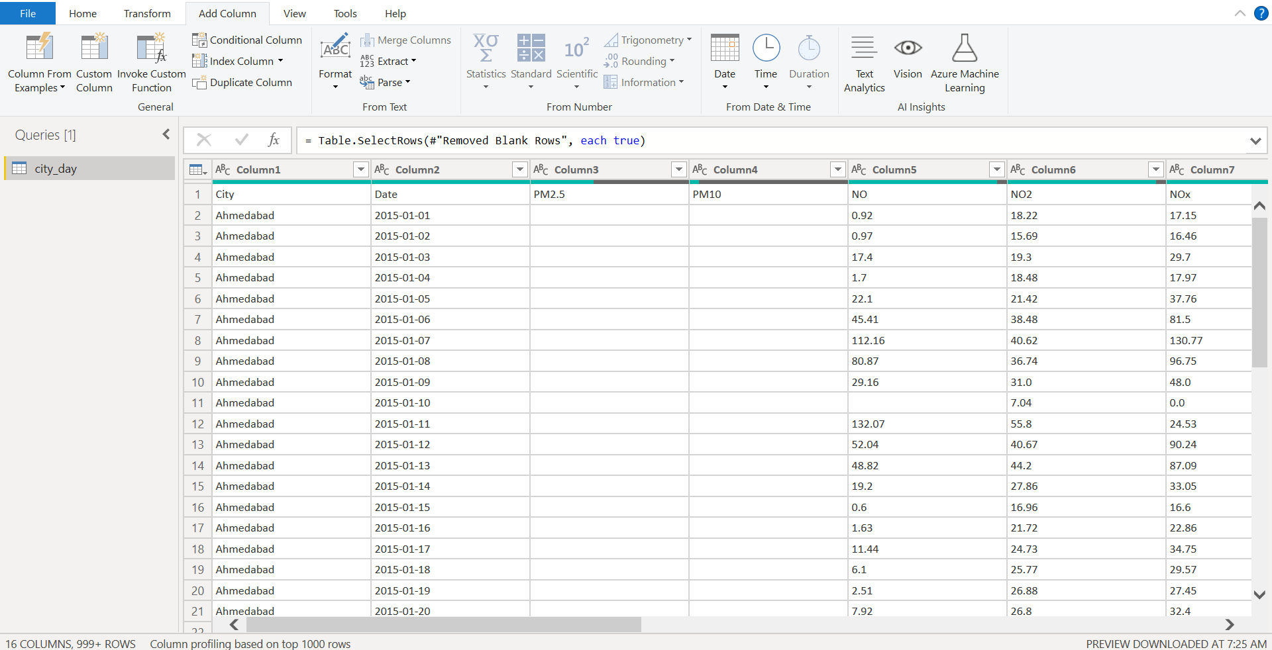

Figure 2.1. Raw Dataset in Power Query Editor

To select a better column for the process, the columns are examined. The column with the crucial values for the analysis is called the AQI bucket. Thus, by utilizing the Row Filter option, the empty cells and null values in the AQI Bucket column are eliminated. Additionally, this will eliminate the empty and null cells in the AQI column as shown in figure 2.2.

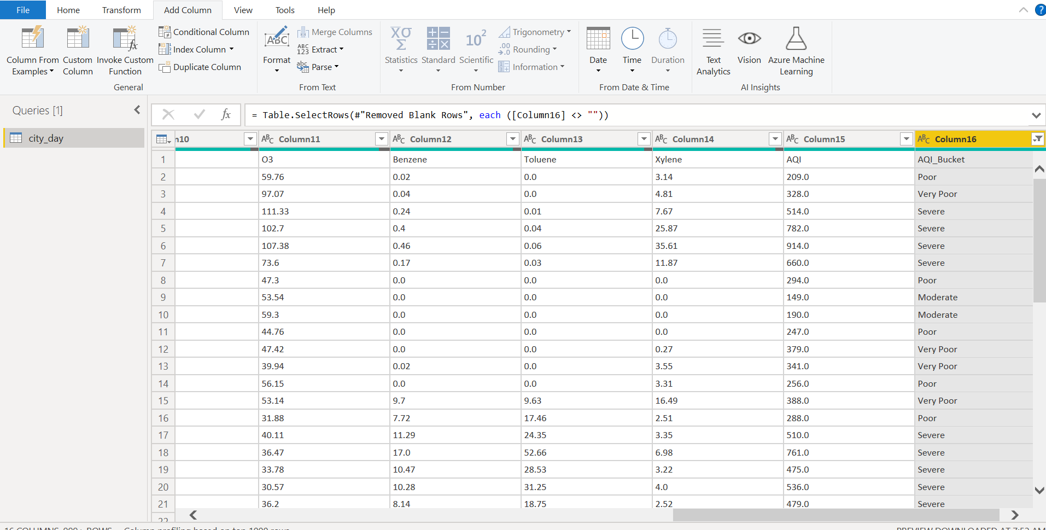

Figure 2.2. Initial removal of Null and Blank Values

The null and blank values are likewise removed from the remaining rows by filtering. Blank cells and null values alone were eliminated because the dataset contains no error values. Now that every null and blank cell has been deleted from the dataset, it is almost ready for analysis. The following figure (fig 2.3) represents the above-mentioned process.

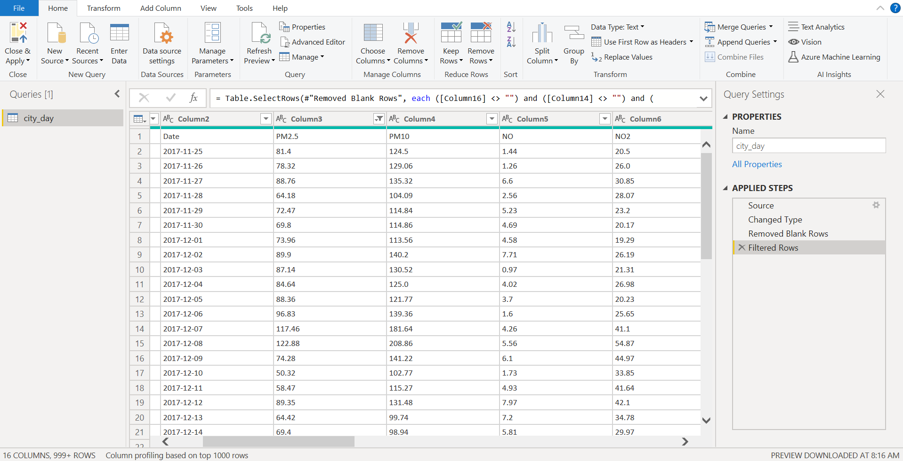

Figure 2.3. Dataset with completing Data Cleaning process

## DATA TRANSFORMATION

Data transformation is the process of converting data from one format or structure to another. The majority of data management and integration tasks, such as application integration, data wrangling, data warehousing, and data integration, all depend on it. Data transformation can be simple or complex, depending on the changes that must be made to the data between the source (original data) and the destination (final data). Both human and automated processes are frequently used in the data translation process. A wide number of methods and technologies may be used, depending on the format, structure, complexity, and quantity of the data being modified.

The dataset's first row currently has the column name as the header; to modify this, select Use First Row as Headers from the menu bar, as shown in Figure 2.4. The date column is duplicated to yield two additional columns. Month and year are used as new names for the duplicate columns. Then, using the Transform option in the dropdown menu, the columns are changed to represent the year and month, respectively. Month names are substituted for the numerical values in the month column. It was done by selecting the Replace value option and changing the value to text. The outcome of this procedure is depicted in Figure 2.5.

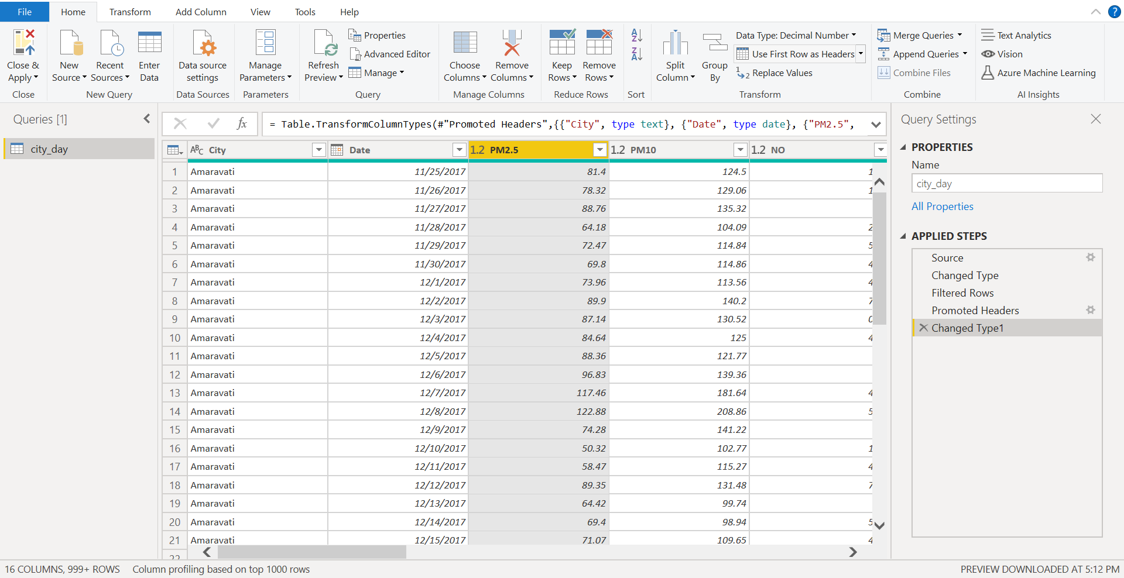

Figure 2.4. First row is changed as Headers

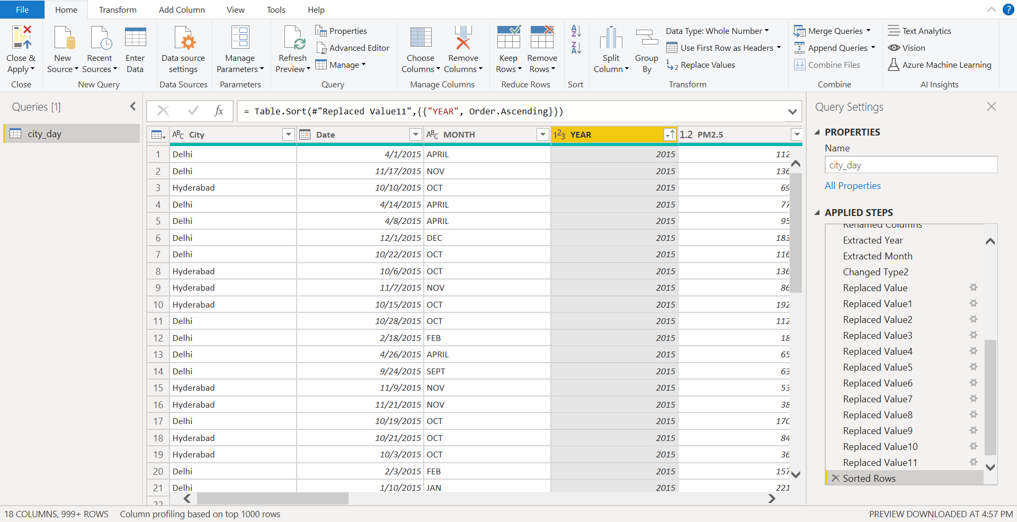

Figure 2.5. Month and Year column are created

The table has now been divided into five separate tables, each bearing the names of the cities of 2015, 2016, 2017, 2018, 2019, and 2020, respectively. Additionally, filter each table so that it only contains the year's data using the Filter Option. This will make it simpler to classify the year-by-year data in Figure 2.6's data.

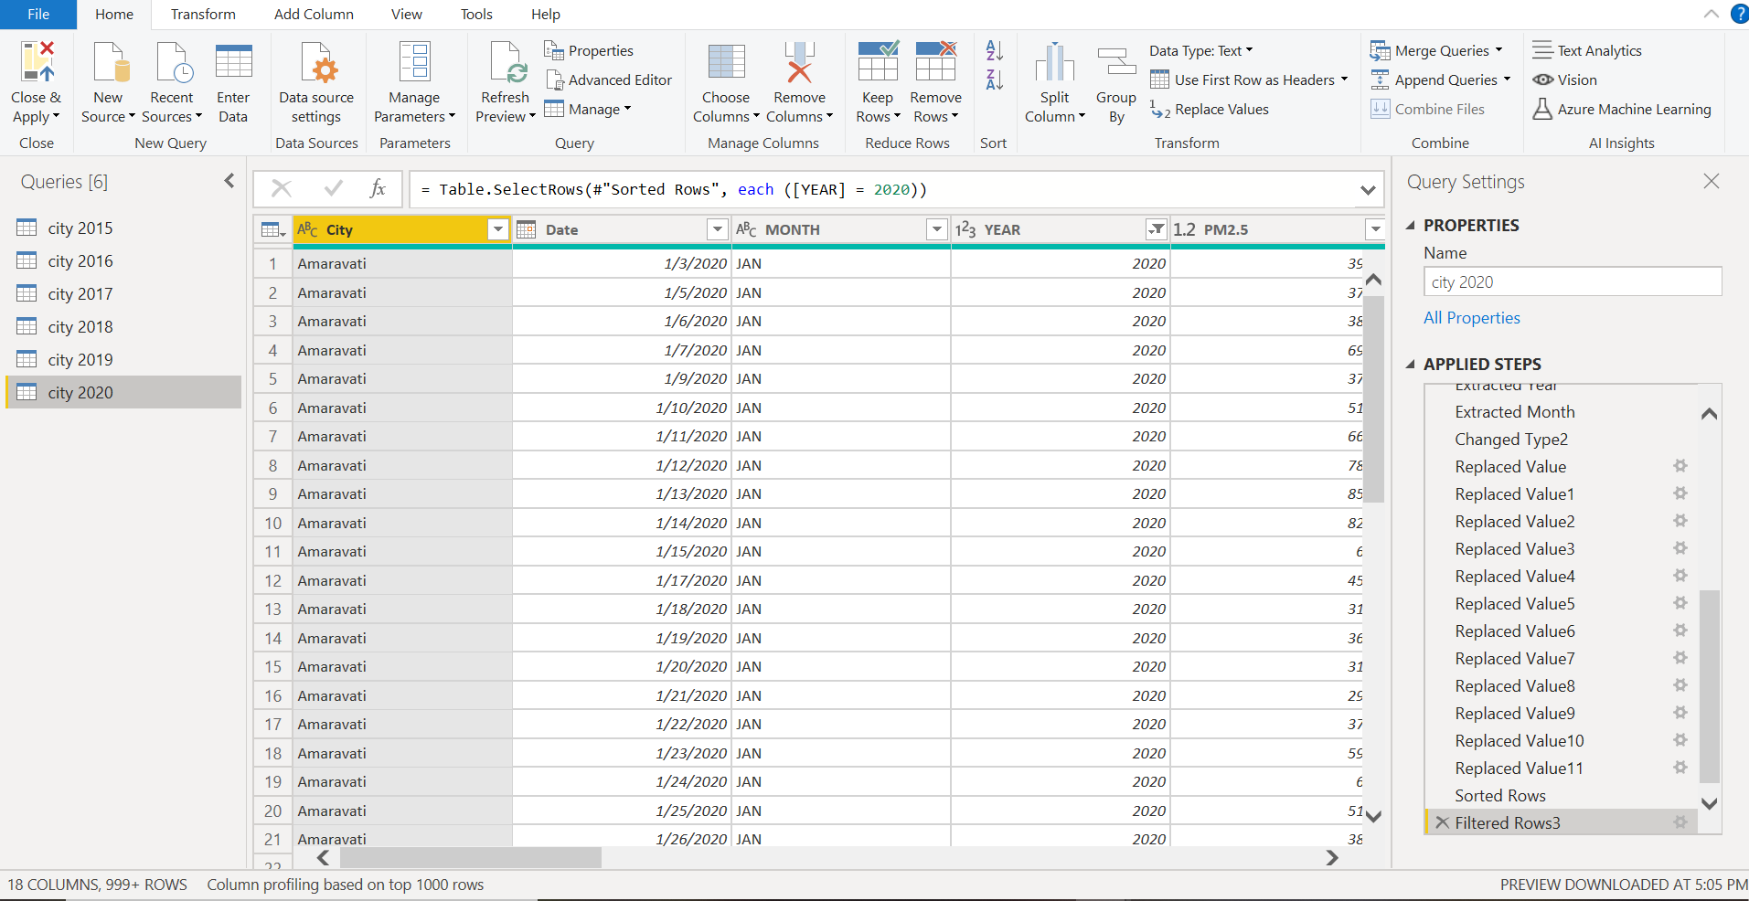

Figure 2.6. Tables for analysis are created

## DATA MODELLING

## The process of analyzing and defining all the many types of data your business generates and gathers, as well as the relationships between those data pieces, is known as "data modeling." Data modelling is a technique for understanding and describing your data needs. It also creates visual representations of the information as it is used at your business. By modelling your data, we can explain the data you have, how you use it, and your usage, security, and governance requirements.

## Five relationships have been established in the dataset's table. Finding the shared characteristic between the tables first will make it easier to build relationships. The city is the characteristic that is used as the main key when forming relationships. Since we can't extract a value from the database from this property using just the data, it won't be feasible to create relationships if we go with additional characteristics like date, PM2.5, AQI, and so on. As a result, the city is chosen to establish relationships between the tables. It establishes a many-to-many link. To help, the tables should be linked together. The Figure 2.7 represents the relationship among the table.

## 

## Figure 2.7. Relationship between tables

# CHAPTER 3

# DATA ANALYSIS AND INTERPRETATION

## DATA ANALYSIS

## Data analysis is the process of examining, cleaning, manipulating, and modelling data in order to uncover pertinent information, support inferences, and assist with decision-making. Business, science, and social sciences all use data analysis, which has a wide range of applications and approaches. It employs a variety of methods and goes by numerous names. In the contemporary corporate world, data analysis aids in more scientific decision-making and more effective business operations.

## Two categories are used to analyze the dataset. They are the Pollutants category and the AQI Bucket Status category. The study of air quality from 2015 to 2020 can be done using the AQI Bucket status. This will provide us a clear understanding of what the air quality index (AQI) is, how it is calculated, and how it displays the amount of danger in the air. Pollutants in the air play a major role in determining the quality of the air. Therefore, the category of pollutants provides information on the types of pollutants, their effects on the quality of the air, and their methods of polluting. The analysis are as follows.

## 3.1.1 AQI Bucket Category Analysis

## 1. What is the AQI bucket value during the years 2015, 2016 and 2017?

## Clustered column charts are chosen for this investigation. From each table, the years 2015, 2016, and 2017 were picked, and they were then moved to the X-axis. The AQI bucket is then moved across the Y-axis. The visual is displayed in Figure 3.1.

## 

## Figure 3.1. AQI Bucket during 2015, 2016 and 2017

## 2. What is the AQI bucket status at the year 2020?

## The year 2020 is picked from the table, and the city 2020 is dragged to the X-axis before the bar chart is chosen for the visualization process. The city count is moved to the y-axis, and the AQI bucket is dragged to legend, correspondingly. The visual is displayed in Figure 3.2.

## 

## Figure 3.2. AQI Bucket status in 2020

## 3. How the quality of air is determined by CO?

## For visualization, a clustered column chart was used. The CO bucket is moved to the Y-axis, while the AQI bucket is moved to the X-axis. The visual is displayed in Figure 3.3.

## 

## Figure 3.3. Air Quality based on CO

## 4. Compare the AQI bucket value of Delhi and Hyderabad in the year 2015.

## The year 2015 is picked from the table city of 2015 and dragged to the Y-axis on the clustered column chart. The city is added to the legend, and the AQI value is moved to the X-axis. The visual is displayed in Figure 3.4.

## 

## Figure 3.4. AQI Bucket comparison between Delhi and Hyderabad in 2019

## 5. Which city has the highest AQI value in the year 2018?

## Once the pie chart visual is selected, the city is dragged to the legend, and the AQI values from the city's 2018 table are displayed. Figure 3.5 depicts the illustration.

## 

## Figure 3.5. City with highest AQI value

## 6. Compare the value of AQI Value with AQI bucket status during the year 2018.

## The AQI bucket is moved from the table city of 2018 to the X-axis, AQI to the Y-axis, and 2018 to the legend, then the line and stacked column charts are selected. The image is displayed in figure 3.6.

## 

## Fig 3.6. Comparison of AQI and AQI bucket in 2018

## 3.1.2 Pollutants Category Analysis

**1. Which city has highest NO and NO2 content in its air during the month of Jan 2020?**

Select the clustered column chart, then drag the city and date (month, year) from the table, 2020, to the X-axis, and NO and NO2 to the Y-axis. It is seen in Figure 3.7.

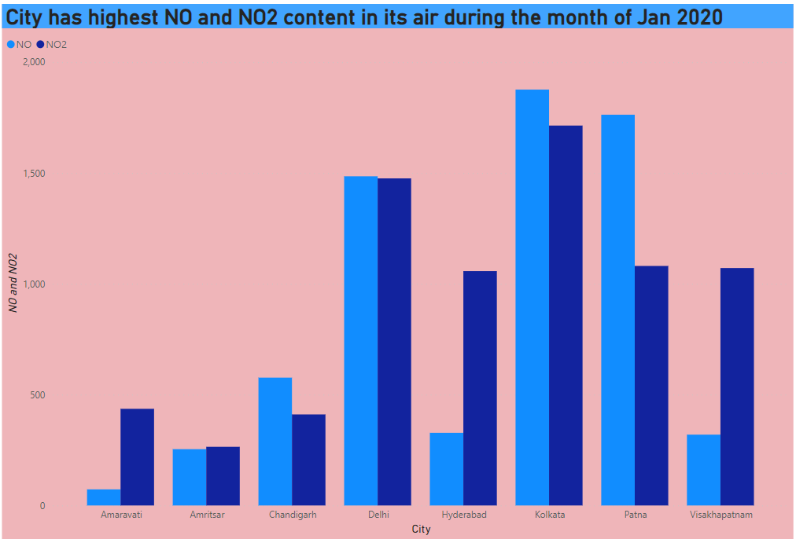

Figure 3.7. City with High NO and NO2 content during Jan 2020

**2. Compare the values of NO2 in the month December of years 2015, 2016, 2017 and 2018.**

The analysis has chosen a pie graph. The years 2015, 2016, 2017, and 2018 are dropped into the values together with the tooltip for NO2 and the drill-in via fields for the month of December. The image is displayed in figure 3.8.

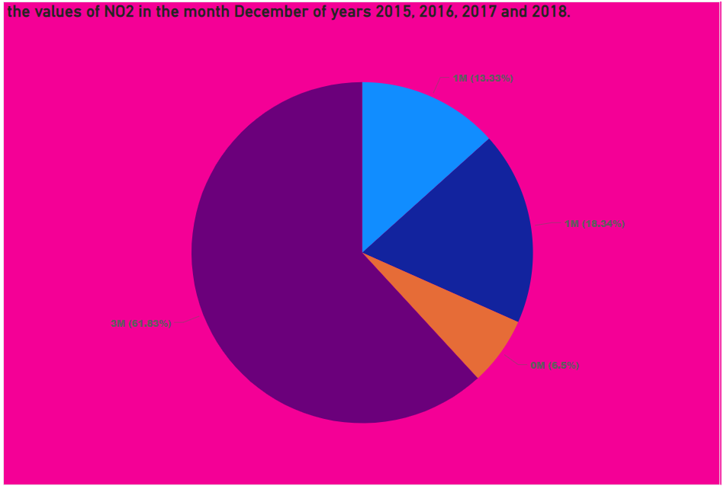

Figure 3.8. Value of NO2 in month December of 2015, 2016, 2017 and 2018

**3. Compare the values of NO and NO2 in the month of Jan 2016.**

Choose a bar chart, then drag the month (January) to the x-axis. Along with it, choose NO2 and then NO, dragging them to the y-axis. The visual is shown in Figure 3.9.

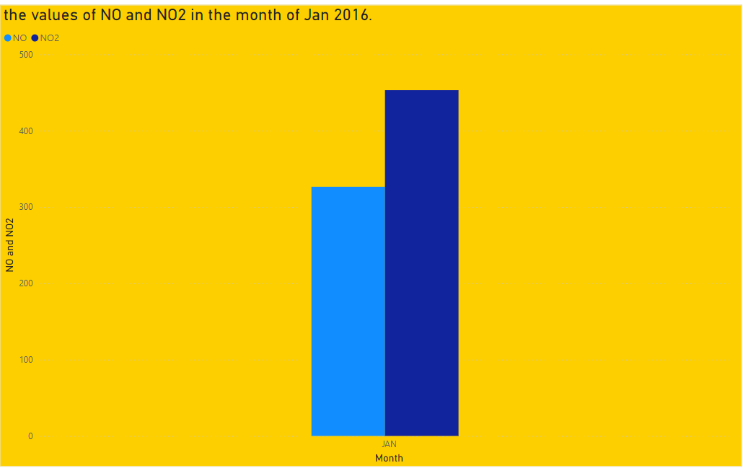

Figure 3.9. Comparison of NO and NO2 value in Jan 2016

**4. What is the Air composition level for all cities of year 2019?**

Select the bar chart, then drag the year 2019 to the x-axis from the table "Cities 2019." Now select every air element and move it to the Y-axis. Figure 3.10 depicts it in pictorial form.

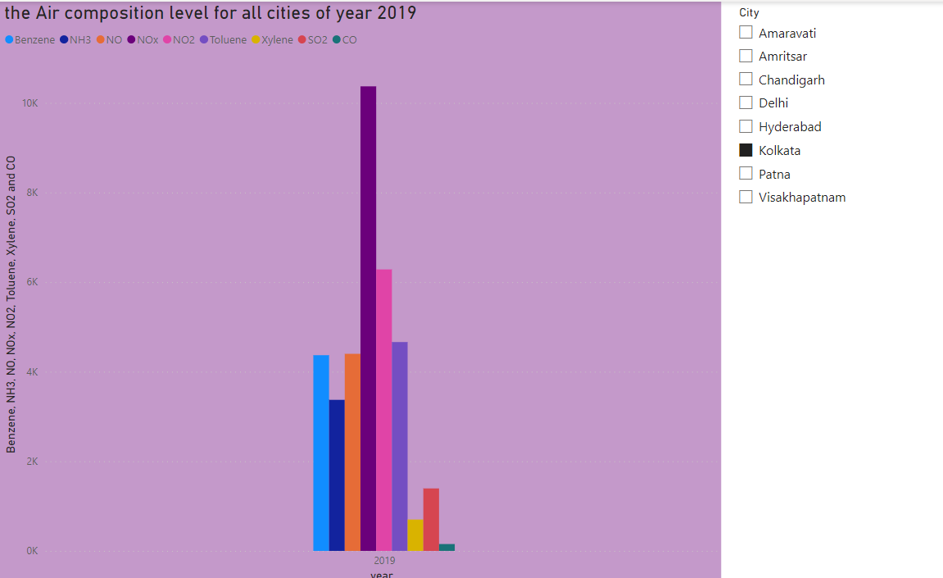

Figure 3.10. Air composition level for all cities in 2019

**5. Which city has the maximum toluene content in its during 2020?**

Drag 2020 to the legend and city to the x-axis after selecting the clustered column chart option. Y-axis toluene should be selected. Figure 3.11 depicts it.

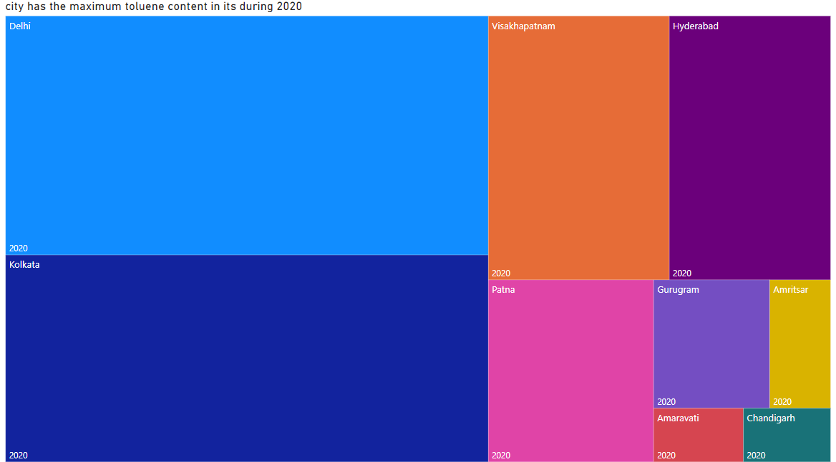

Fig 3.11. City with high toluene content in 2020

**6. Which element causes more pollutant in air at the year 2017?**

Pick the clustered column chart option, then drag the year 2017 from the table to the x-axis. Pick up every air element and move it to the y axis. The visual is depicted in fig. 19.

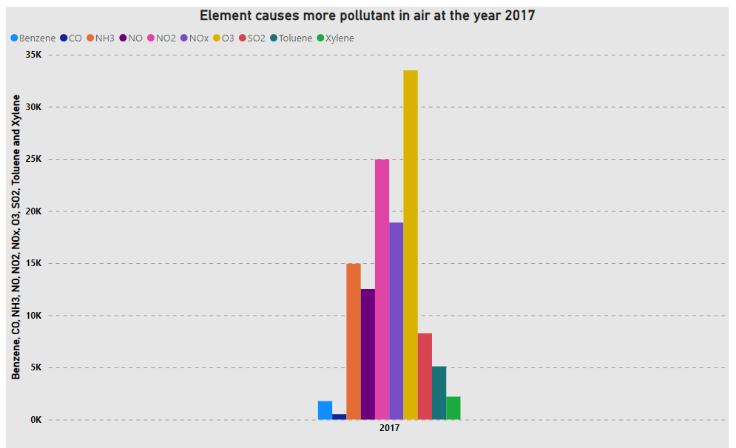

Fig 3.12. Element causing more pollutions in 2017

**7. Compare the level of NO and NO2 in each city during the year 2020.**

Choose the waterfall chart, then slide the AQI bucket to the x-axis. Drag the NO element to the secondary y-axis and pick NO2 for the primary y-axis. The visual is shown in Figure 3.13.

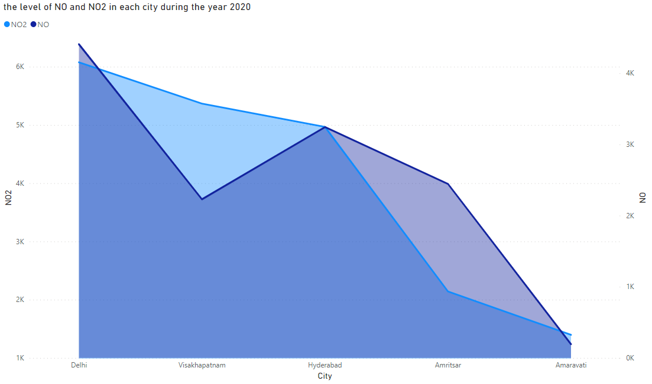

Figure 3.13. Level of NO2 and No in each city during 2020

**8. Compare the amount of air pollutants in the air of each city during the year 2019.**

Choose and move the city from the table "City of 2019" to the X-axis after selecting the clustered column chart. Choose all the pollutants for the y-axis. The visual is depicted in figure 3.14.

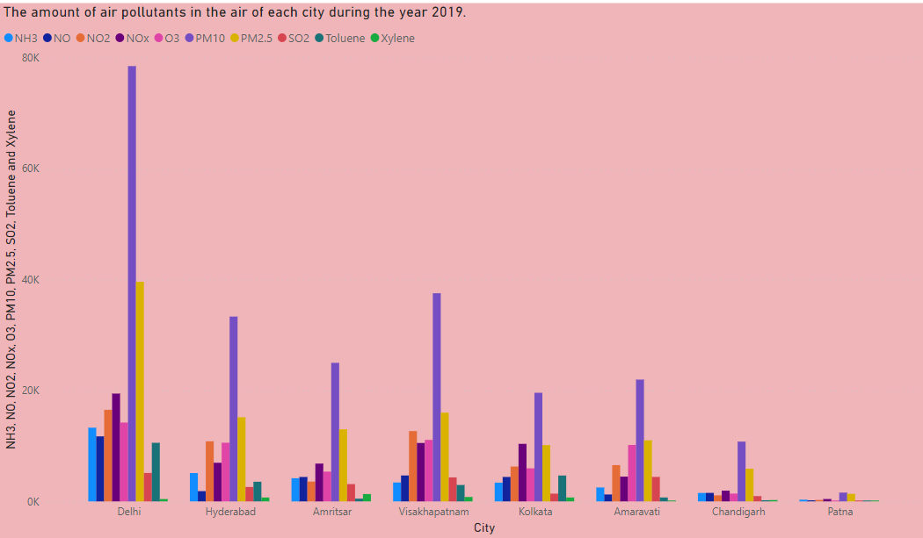

Figure 3.14. Amount of air pollutants in air of each city during 2019

**9. Compare the amount of PM10 of each month in the year 2020.**

Select the pie chart option, then drag the year 2020 from the "city 2020" table to the details. then pick PM10 and drag it to the legends and values fields, respectively. The visual is depicted in figure 3.15.

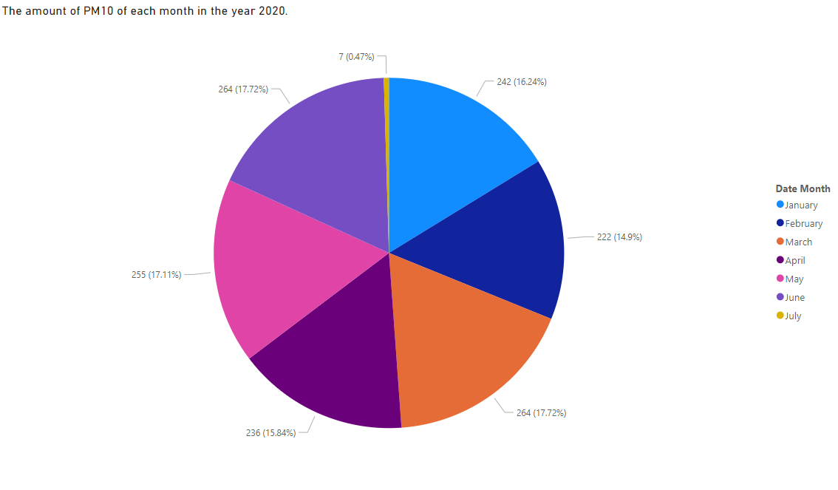

Figure 3.15. Amount of PM10 content for each month in the year 2019

**10. What is the level of CO and NO in each city during 2017?**

Choose the area chart, then click and drag the city to the table's x axis and the CO to its y axis in 2017. The NO has been moved to the Y-axis. The visual is shown in figure 3.16.

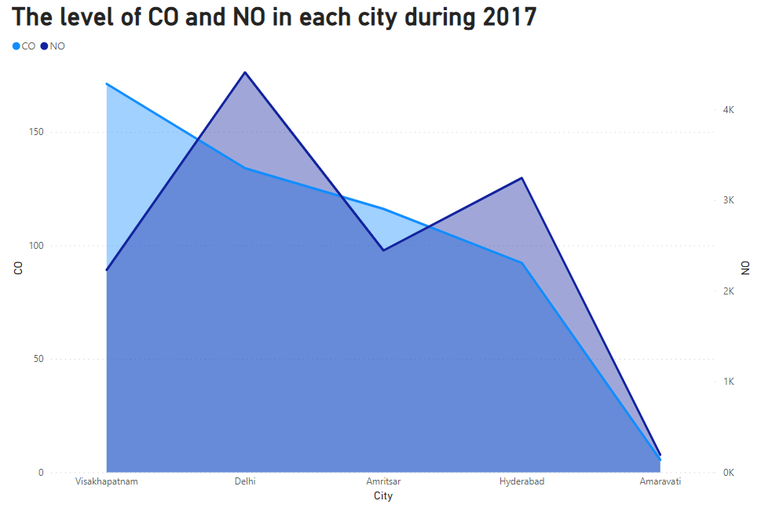

Figure 3.16. Level of CO and NO in each city during 2017

**11. Compare the SO2 and PM2.5 by month in the year 2018.**

Select the clustered column chart option, then drag the month to the x axis. Drag PM2.5 and SO2 to the y axis while selecting them both. Drag the city into the field after adding the slicer visual. The visualization is displayed in Figure 3.17.

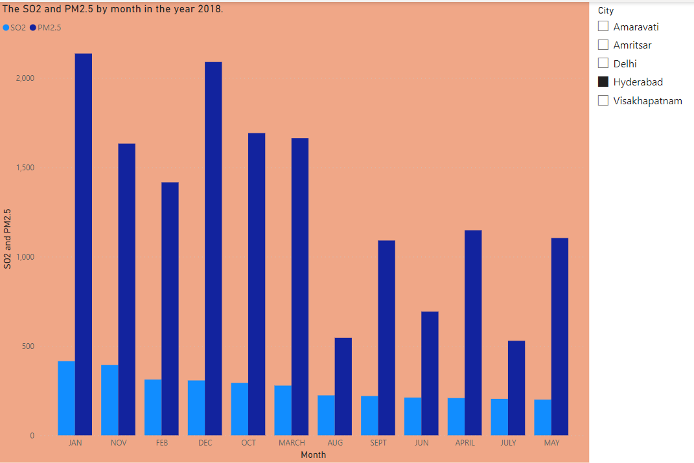

Figure 3.18. Comparison of SO and PM2.5 in year 2018 for each month

**12. In 2019, which city has the highest NOx value?**

Select the clustered column chart option, then drag the year 2019 to the x axis. Y-axis NOx should be added. drag a city into the legend after choosing it. The image shown above is represented by figure 3.18.

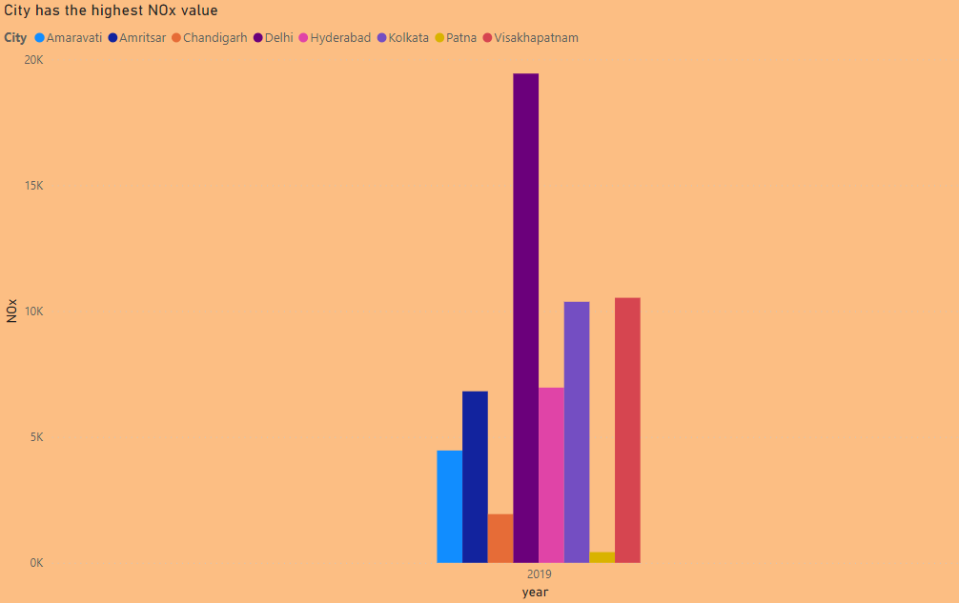

Fig 3.18. City with highest NOx value in 2019

**13. What is the amount of toluene and xylene in air during the summer season of 2015?**

Decide on a clustered column chart, then pick a month (March, April, May) from the 2015 city table and drag it to the x axis. Drag xylene and toluene to the y axis after selecting them. The image is displayed in figure 3.19 below.

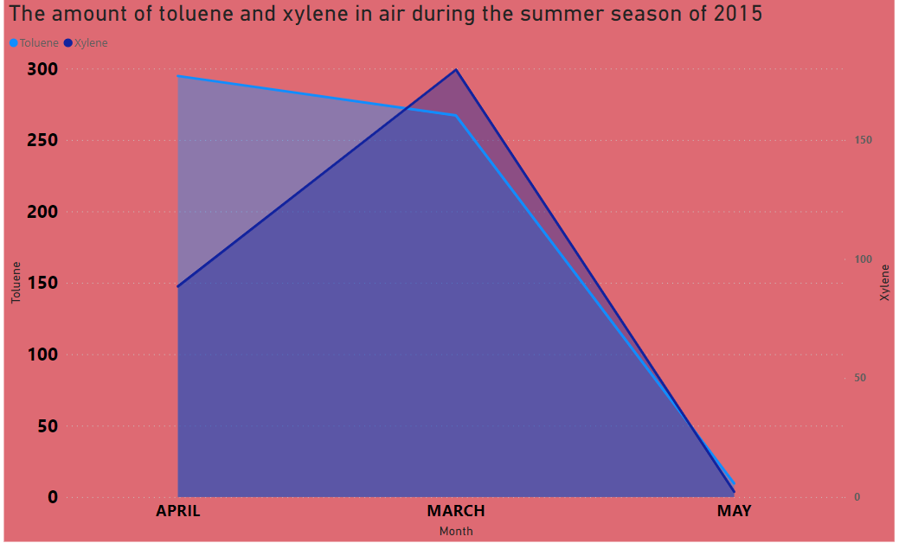

Figure 3.19. Amount of toluene and xylene in air during summer months of 2015

**14. What is the amount of benzene content in air during the winter season of 2015?**

Select the clustered column chart option, then drag the year 2015 from the city 2015 table to the x axis. Drag one month to the legend and one benzene to the y axis, respectively. This illustration is shown in figure 3.20.

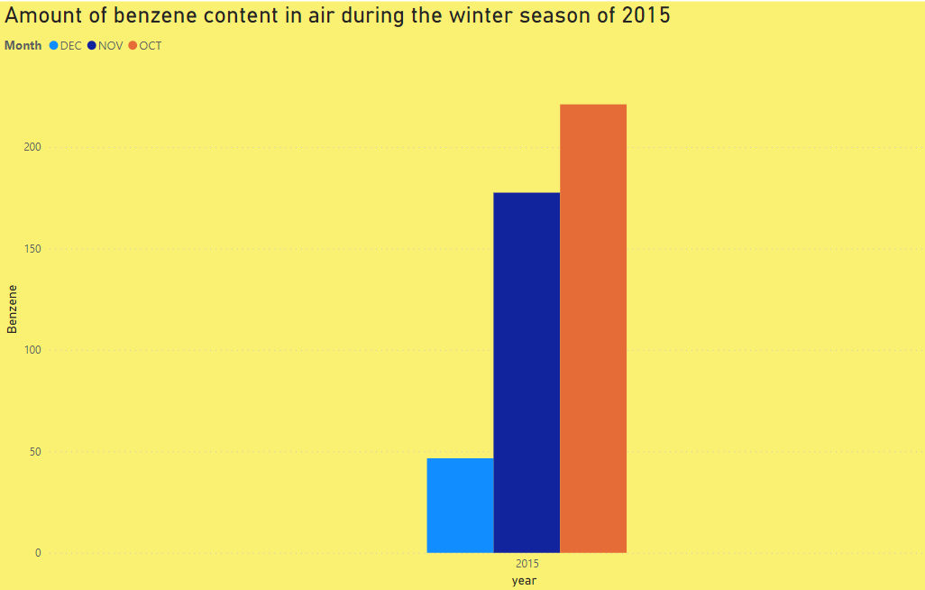

Figure 3.20. Amount of benzene in air during the winter of 2015

## PUBLISHING DASHBOARD

## Creating and distributing a report view (read-and-execute-only) of a notebook is required to publish a dashboard. Users (consumers) who are not account owners of PowerBi can utilize the resultant dashboard. A Power BI report is shared with other users at powerbi.com by being "pushed" to the cloud. Publishing with this program does not necessarily mean posting it online.

## The following are the steps needed to publish a dashboard using PowerBi's web service. If not already, log in to Power BI. Decide where you want to go. In order to locate the workspace into which you wish to publish, one can search your list of accessible workspaces. One’s workplaces may be filtered using the search box. To publish, choose the workspace and then click the Select button. One gets a link to your report after posting is complete. To view the report in your Power BI site, choose the link. One may also upload the PowerBi file to the PowerBi online service website, build a dashboard, and call it the Air quality Index Dashboard by pinning the images to the new dashboard. A Power BI dashboard is a single page, also known as a canvas, that uses visuals to convey a story. A well-designed dashboard presents only the highlights of the tale because it can only fit on one page. For further information, readers may see linked reports. The Power BI service has a feature called dashboards. Figure 3.21 displays the PowerBi dashboard that has been published.

## 

## Figure 3.21. Air Quality Index Dashboard

## INFERENCES

## 3.3.1 AQI Bucket Category Analysis

## 1. What is the AQI bucket value during the years 2015, 2016 and 2017?

## The six levels of the AQI index are "Good", "Satisfactory", "Moderately polluted", "Poor", "Very Poor", and "Severe". A certain range was chosen for each of the contaminants in order to group them into the six buckets. GOOD-101, POOR-203, VERY POOR-203, MODERATE-304, and SATISFACTORY-304 were the values for 2015. 2016 values were GOOD (417), POOR (168), VERY POOR (168), MODEST (418), and SATISFACTORY (418). In 2017, the results were GOOD-610, POOR-316, VERY POOR-250, MODERATE-707, and SATISFACTORY-707.

## 2. What is the AQI bucket status at the year 2020?

## In the year 2020, the scores were GOOD 188, POOR 111, VERY POOR 35, MODERATE 511, and SATISFACTORY 614.

## 3. How the quality of air is determined by CO?

## CO is a factor in determining the air's quality. The Air Quality Index, or AQI, is used to assess how bad the air is. The AQI functions similarly to a thermometer with a range of 0 to 500 degrees.

## 4. Compare the AQI bucket value of Delhi and Hyderabad in the year 2015.

## Delhi is quite poor in comparison to other cities, Very Poor (301-400) - May result in respiratory disease in those exposed for an extended period. People with lung and heart conditions may experience the effect more strongly.

## 5. Which city has the highest AQI value in the year 2018?

## The city with the highest air quality index (AQI) score in 2018 is Delhi. The higher the AQI score, the more serious the air pollution is for human health.

## 6. Compare the value of AQI Value with AQI bucket status during the year 2018.

## Most of the time, the AQI bucket value is moderate. Most of the time, the air quality falls into the moderate, bad, and acceptable categories. As a result, 2018's air quality is a mix of terrible and good.

## 3.3.2 Pollutants Category Analysis

**1. Which city has highest NO and NO2 content in its air during the month of Jan 2020?**

Kolkata's air has the highest NO and NO2 concentrations in January 2020. The quantity of oxygen that can be carried in the bloodstream to vital organs like the heart and brain is decreased when breathing air with a high CO content. The odorless, acidic, and extremely corrosive gas known as nitrogen dioxide has an impact on both human health and the environment. Nitrogen oxides have a key role in photochemical smog.

**2. Compare the values of NO2 in the month December of years 2015, 2016, 2017 and 2018.**

The levels of nitrogen dioxide in December of 2018 were unusually high. High levels of nitrogen dioxide can harm the human respiratory system and make someone more susceptible to and more severely affected by respiratory illnesses and asthma.

**3. Compare the values of NO and NO2 in the month of Jan 2016.**

The NO and NO2 figures for the month of January 2016 is high. Nitric oxide is quickly oxidized in the air by accessible oxidants (including oxygen, ozone, and VOCs) under ambient circumstances, and because of this high oxidation velocity, nitrogen dioxide is typically regarded as a major pollutant.

**4. What is the Air composition level for all cities of year 2019?**

In every city in 2019 there is a high NOx element level. There are different amounts of NOx, NO2, Benzene, NH3, Xylene, Toluene, SO2, and CO in each city. Nitric acid, nitrous acid, and nitrogen dioxide are among the extremely reactive gasses known as nitrogen oxides (NO x). The EPA employs nitrogen dioxide (NO 2) as a standard-setting parameter. As an "indicator pollutant," nitrogen dioxide implies that other nitrogen oxides are also polluting the air.

**5. Which city has the maximum toluene content in its during 2020?**

In 2020, Delhi's air has the highest toluene concentration. The highest concentration of toluene in the air can result in fatigue, sluggishness, trouble falling asleep, numbness in the hands or feet, harm to the female reproductive system, and miscarriage. Toluene can harm the liver and kidneys if it is ingested.

**6. Which element causes more pollutant in air at the year 2017?**

Ozone causes greater air pollution in 2017 than O3. Ozone can tighten the muscles in the airways, trapping air in the alveoli. Wheezing and breathing difficulties result from this. Ozone exposure varies in its ability to: Lead to sore or scratchy throats and coughing.

**7. Compare the level of NO and NO2 in each city during the year 2020.**

In the month of January 2020, PATNA's air has the highest levels of NO and NO2, and NO had a The quantity of oxygen that can be carried in the bloodstream to vital organs like the heart and brain is decreased when breathing air with a high CO content. The odorless, acidic, and extremely corrosive gas known as nitrogen dioxide has an impact on both human health and the environment. Nitrogen oxides have a key role in photochemical smog.

**8. Compare the amount of air pollutants in the air of each city during the year 2019.**

In each city throughout the year 2019, the amount of air pollution is present in Delhi. As the AQI rises, there are more dangers to the general public's health, particularly for young children, the elderly, and people who already have respiratory or cardiovascular conditions. Governmental organizations typically advise citizens to limit or even eliminate outdoor physical exercise during certain periods.

**9. Compare the amount of PM10 of each month in the year 2020.**

Dust and smoke include PM 10 particles, which are incredibly minute. They are 10 micrometers (0.01 mm) in diameter or smaller. A typical type of air pollution is PM 10 particles. At several of our air monitoring locations, we measure PM 10. Numerous health effects, including coughing and wheezing, asthma attacks, bronchitis, high blood pressure, heart attacks, strokes, and early death, can be brought on by exposure to high concentrations of PM10. The PM10 readings are as follows at each level. The amount of PM10 in January is 16.24 percent. PM10 is present in 14.9% of the air in February. The amount of PM10 is 17.72% in the month of March. The amount of PM10 is 15.84% in the month of April. The amount of PM10 is 17.11% in the month of May. The amount of PM10 is 17.72% in the month of June. The amount of PM10 is 0.47 percent in the month of July.

**10. What is the level of CO and NO in each city during 2017?**

You cannot taste, smell, or see carbon monoxide (CO), a hazardous gas. It results from incomplete combustion, which happens when carbon-based fuels like kerosene, gasoline, natural gas, propane, charcoal, or wood are burnt. The major sources of NO are combustion processes, partially from fuels containing nitrogen compounds and directly from the direct reaction of nitrogen in flames with oxygen in the air. Humans do not release nitrogen monoxide, even though it is likewise created in the human body. The NO level is at its highest in the cities, which may enhance susceptibility to respiratory infections and contribute to the development of asthma. Children, the elderly, and those who have asthma are often more vulnerable to the negative effects of NO2. Vishakhapatnam is a city with a NO of 2228.91 and a CO of 171.26. Delhi's NO and CO are 4407.09 and 134.01, respectively. Amritsar's NO is 2444.44 and its CO is 116.14. Hyderabad's NO is 3243.38 and its CO is 92.24. The NO and CO for Amaravati are 192.28 and 5.45, respectively.

**11. Compare the SO2 and PM2.5 by month in the year 2018.**

Sulfur dioxide is an odourless gas or liquid that is also referred to as SO2. It is produced by burning fossil fuels (coal and oil) and smelting mineral ores that contain sulphur (aluminum, copper, zinc, lead, and iron). Sulfuric acid can easily created by mixing water with sulphur dioxide. The health of humans is at danger when the amount of tiny particulate matter (PM 2.5) in the air is excessive. When levels are high, PM 2.5, which are microscopic airborne particles, decrease visibility and make the air look foggy. These are the values: The PM2.5 level is 1680.27 and the SO2 level is 84.48 in the month of JAN. In October, the PM2.5 and SO2 concentrations are 550.86 and 65.94, respectively. PM2.5 level is 1175.88 and SO2 level is 77.5.9 in the month of DEC. The conclusion demonstrates that PM2.5 levels are at their highest at this time of year, which can lead to early death, an increase in hospital admissions for heart or lung conditions, acute and chronic bronchitis, asthma episodes, ER visits, respiratory symptoms, and days of restricted activity.

**12. In 2019, which city has the highest NOx value?**

Air pollution is fundamentally made up of hazardous gas molecules known as nitrogen oxides (NOx), which are chemical compounds between oxygen and nitrogen. The city with the highest NOx value in 2019 was Delhi, with a level of 19435.40, as seen in the above graphic. Delhi's elevated NOx levels result in fast burning, spasms, and swelling of the throat and upper respiratory tract tissues, decreased oxygenation of body tissues, an accumulation of fluid in the lungs, and eventual death.

**13. What is the amount of toluene and xylene in air during the summer season of 2015?**

Toluene, sometimes called toluol, is an aromatic hydrocarbon that has been replaced. It is a colorless, insoluble in water liquid with a paint thinner-like odor. An example of an organic chemical is xylene. It is sometimes referred to as Xylol or dimethylbenzene. It is one of the three dimethyl benzene isomers. These are the values: Toluene levels are 267.13 and Xylene levels are 179.52 in MAR. The levels of toluene and xylene are 294.80 and 88.49 respectively in APR. Toluene levels are 9.50 and Xylene levels are 2.21 in MAY. The highest concentration of toluene in the air can result in fatigue, sluggishness, trouble sleeping, numbness in the hands or feet, harm to the female reproductive system, and miscarriage. Toluene can harm the liver and kidneys if it is ingested.

**14. What is the amount of benzene content in air during the winter season of 2015?**

The fragrance of gasoline is in part due to benzene, a colorless, extremely combustible chemical with a pleasant scent. In a lab setting, benzene has been demonstrated to alter the chromosomes of bone marrow cells. (New blood cells are produced in the bone marrow.) These modifications are frequently observed in human leukemia cells. Benzene exposure in the workplace is a major issue for occupational health worldwide. Benzene targets organs such as the liver, kidney, lung, heart, and brain after inhalation or absorption. By way of the cytochrome P450 multifunctional oxygenase system, it is mostly processed in the liver. These are the values: The concentration of benzene in OCT is 221.05. The concentration of benzene in NOV is 177.52. The concentration of benzene in DEC is 46.59.

# CHAPTER 4

# CONCLUSION AND FUTURE WORK

**4.1 RECOMMENDATIONS**

Concerns regarding air pollution have been expressed in relation to the environment and human health, particularly in urban areas. To lower the rapidly rising levels of air pollution, the government sought to restrict how individuals used their automobiles. It is difficult to predict that this air pollution will lead to a major catastrophe. To lessen air pollution, the government must encourage people to utilize public transit. The government must enhance public transportation since simply encouraging the use of it won't help reduce air pollution.

# REFERENCES

1. Y.L. Zhang et al. Is it time to tackle PM(2.5) air pollution in China from biomass-burning emissions? Environment Pollutions.(2015).
2. F. Pariselli et al. Effects of toluene and benzene air mixtures on human lung cells (A549) Experimental and Toxicologic Pathology (2009).
3. H. Wang et al. Spatial and temporal patterns as well as major influencing factors of global and diffuse Horizontal Irradiance over China: 1960-2014 Sol. Energy (2018).
4. L. Trasande et al. The role of air pollution in asthma and other pediatric morbidities Journal of Allergy and Clinical Immunology (2005).
5. WHO (2000) Air quality guidelines for Europe, 2nd edition. Copenhagen, WHO Regional Office for Europe, WHO Regional Publications, European Series, No. 91.
6. O. Wong et al. Exposure to benzene and non-Hodgkin lymphoma, an epidemiologic overview and an ongoing case-control study in Shanghai Chemico-Biological Interactions (2005).
7. G. Polichetti et al. Effects of particulate matter (PM10, PM2.5 and PM1) on the cardiovascular system Toxicology (2009).
8. World Health Organization (WHO) (2014). World health statistics 2014. <https://www.who.int/gho/publications/world_health_statistics/2014/en/>.
9. Gupta, I., & Kumar, R. (2006). Trends of particulate matter in four cities in India. Atmospheric Environment, 40, 2552–2566.
10. T.C. Borbet et al. Assessing air quality index awareness and use in Mexico City BMC Publ. Health (2018).
11. Castro, N. Künzli, T. Götschi. "Health benefits of a reduction of PM10 and NO2 exposure after implementing a clean air plan in the Agglomeration Lausanne-Morges" International Journal of Hygiene and Environmental Health 220 (2017): 829-839.
12. A.F. Pennington et al. Communication channels for air quality alerts in the United States Prev. Med. Rep. (2019).
13. Bruno, F., & Cocchi, D. (2002). A unified strategy for building simple air quality indices. Environmetrics, 13(3), 243–261.
14. Qian X, Xu G, Li L, Shen Y, He T, Liang Y, Yang Z, Zhou WW, Xu J. Knowledge and perceptions of air pollution in Ningbo, China. BMC Public Health. 2016;16(1):1138.
15. Dockery, D. W., & Stone, P. H. (2007). Cardiovascular risks from fine particulate air pollution. The New England Journal of Medicine, 356, 511–513. <https://doi.org/10.1056/NEJMe068274>.
16. DalilaTaieb, Ammar Ben Brahim, Methodology for developing an air quality index (AQI) for Tunisia. Int. J. Renewable Energy Technology, Vol. 4, No. 1, (2013).
17. Fitz-Simons, T. (1999). Guideline for reporting of daily air quality: air quality index (AQI) 99/010). Resource document.. Environmental Protection Agency (United States). <https://www.osti.gov/biblio/698786>.
18. F. Famoso, R. Lanzafame, P. Monforte, P.F. Scandura Air quality data for Catania: analysis and investigation case study 2010-2011. Energy Procedia;, 45 (2014), pp. 681-690.
19. Lanzafame, R., Monforte, P., & Scandura, P. F. (2016). Comparative analyses of urban air quality monitoring systems: Passive sampling and continuous monitoring stations. Energy Procedia, 101, 321–328.